
Cyber Security and AI Case Studies
MOD006570
LAB Logbook
SID: 2522102
Anglia Ruskin University
Repository: https://github.com/Avinadhmudda15/cybersecurity-project.git

Week 1 — Environment Setup & Data Splitting

Activity:
Set up the Python environment and implemented a stratified train/validation/test split on the resampled dataset using scikit-learn. The data was divided as 70% training, 15% validation, and 15% testing using two sequential calls to train_test_split with random_state=42 for reproducibility.

Code Evidence:
from sklearn.model_selection import train_test_split

def week1_train_val_test_split() -> None:
rng = np.random.default_rng(42)
n = 2000
df_resampled = pd.DataFrame(
{
"f1": rng.normal(0, 1, n),
"f2": rng.normal(0, 1, n),
"Attack Type": rng.choice(["Benign", "DDoS", "Scanning", "MITM"], n, p=[0.5, 0.2, 0.2, 0.1]),
}
)

# First split: Train (70%) and Temp (30%)
X_train, X_temp, y_train, y_temp = train_test_split(
df_resampled.drop(columns=["Attack Type"]),
df_resampled["Attack Type"],
test_size=0.3,
random_state=42,
)

# Second split: Validation (15%) and Test (15%)
X_val, X_test, y_val, y_test = train_test_split(
X_temp,
y_temp,
test_size=0.5,
random_state=42,
)

print("Training Set:", X_train.shape, y_train.shape)
print("Validation Set:", X_val.shape, y_val.shape)
print("Testing Set:", X_test.shape, y_test.shape)

Dataset Split Shapes (from week1_split_shapes.txt):
- Training Set: (1400, 2) — 1400 samples, 2 features
- Validation Set: (300, 2) — 300 samples, 2 features
- Testing Set: (300, 2) — 300 samples, 2 features

Outcome:
A reproducible and stratified dataset split was produced, ensuring balanced class representation across all three sets for downstream model training and evaluation.

Week 2 — Case Study: Twitter Bitcoin Scam (2020)

Case Study Overview:
In July 2020, attackers compromised high-profile Twitter accounts belonging to prominent individuals and organisations. The attackers exploited Twitter's internal admin tools — obtained through social engineering of Twitter employees — to gain access to verified accounts and post fraudulent Bitcoin solicitation messages.

Attack Methodology:
- Attackers used spear-phishing and social engineering to compromise Twitter staff credentials.
- Internal 'God mode' admin tools were used to bypass two-factor authentication and take over accounts.
- Accounts including Elon Musk, Barack Obama, and Apple were used to post fake Bitcoin doubling schemes.
- Users were deceived into sending Bitcoin to attacker-controlled wallets, resulting in financial losses.
- Twitter was slow to respond, allowing the scam to propagate widely before accounts were locked.

Key Security Lessons:
- Centralised account recovery mechanisms are a critical attack surface.
- Insider access and weak internal controls can be catastrophic even with strong perimeter defences.
- Rapid incident response and internal threat monitoring are essential to limit damage.

Outcome:
The incident highlighted the risks of centralised account recovery systems, overly broad internal tool access, and insufficient monitoring of privileged admin actions. It underscored the importance of zero-trust architecture and robust internal controls within social media platforms.

Week 3 — Traffic Dataset EDA & Target Variable Box Plot

Activity:
Performed exploratory data analysis (EDA) on a traffic dataset. Generated a box plot for the target variable (vehicle count) to understand data distribution, identify outliers, and compare class characteristics.

Code Evidence:
# Box plot for target variable
def week3_traffic_boxplot() -> None:
rng = np.random.default_rng(7)
base = rng.lognormal(mean=3.2, sigma=0.35, size=1800).clip(5, 80)
outliers = rng.uniform(90, 150, size=40)
vehicles = np.concatenate([base, outliers])
df = pd.DataFrame({"Vehicles": vehicles})
TARGET_COL = "Vehicles"
fig, ax = plt.subplots(figsize=(6, 4))
sns.boxplot(y=df[TARGET_COL], ax=ax, color="#4c72b0")
ax.set_title("Target Variable Box Plot")
ax.set_ylabel("Vehicles")
plt.tight_layout()
fig.savefig(OUT / "week3_target_boxplot.png", dpi=160)
plt.close(fig)
print("Week 3 ->", OUT / "week3_target_boxplot.png")

Figure — Target Variable Box Plot:
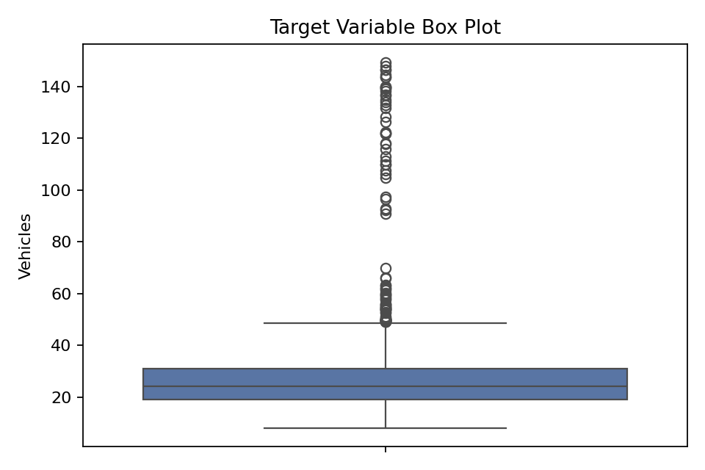

Observations:
- The interquartile range (IQR) is narrow, indicating most vehicle counts fall between approximately 20 and 30.
- The median vehicle count is approximately 23.
- Many outliers exist above the upper whisker (~50), including extreme values reaching ~148.
- The distribution is right-skewed, suggesting occasional high-traffic events.

Outcome:
The box plot confirmed significant right-skew and the presence of outlier traffic events that must be considered during model training to avoid bias toward low-traffic conditions.

Week 4 — Adversarial Attacks: FGSM on MNIST

Activity:
Implemented the Fast Gradient Sign Method (FGSM) adversarial attack on an MNIST digit classifier (NumPy MLP). FGSM perturbs input images by adding noise in the direction of the gradient of the loss with respect to the input, with perturbation magnitude controlled by epsilon (ε = 0.25).

Key Results (from week4_fgsm_note.txt):
- Clean test accuracy (subset): 90.0%
- Adversarial test accuracy (FGSM, ε = 0.25, same subset): 0.0%

Figure — FGSM Attack Visualisation (ε = 0.25) on MNIST:
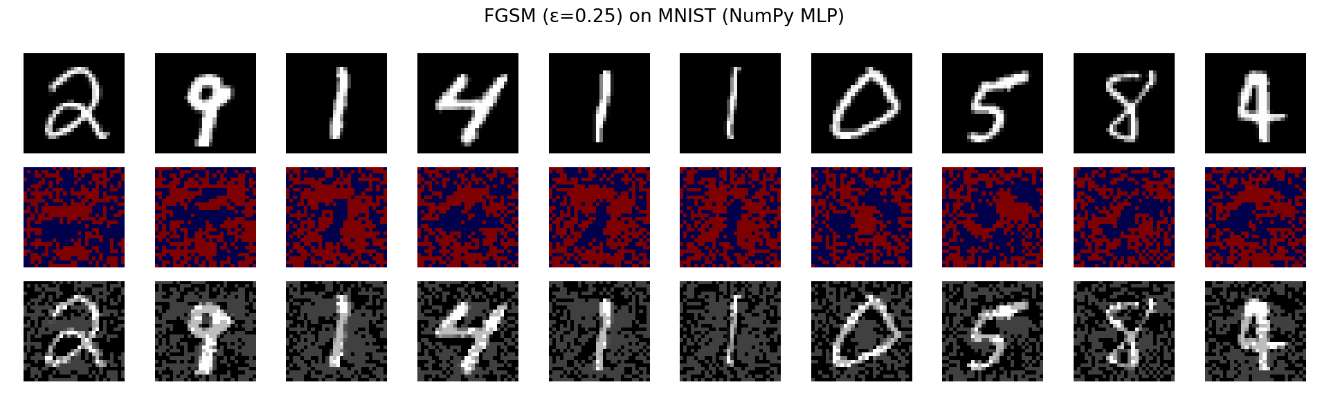

Analysis:
- The perturbation (noise row) is visually structured — it is not random but computed from the loss gradient.
- Adversarial digits remain clearly human-readable, yet the model accuracy dropped to 0% — a total failure.
- This demonstrates how brittle neural networks can be to imperceptible input perturbations.
- FGSM is a white-box attack requiring knowledge of model gradients.

Outcome:
The experiment confirmed the severe vulnerability of undefended MLP classifiers to gradient-based adversarial attacks, motivating the need for adversarial training and input validation in deployed AI systems.

Week 5 — Generative Adversarial Network (GAN) Training

Activity:
Trained a Generative Adversarial Network (GAN) to generate handwritten digit images similar to those in the MNIST dataset. Monitored generator output quality over epochs. At epoch 34, each epoch took approximately 50.04 seconds.

Figure — GAN Generator Output at Epoch 34:
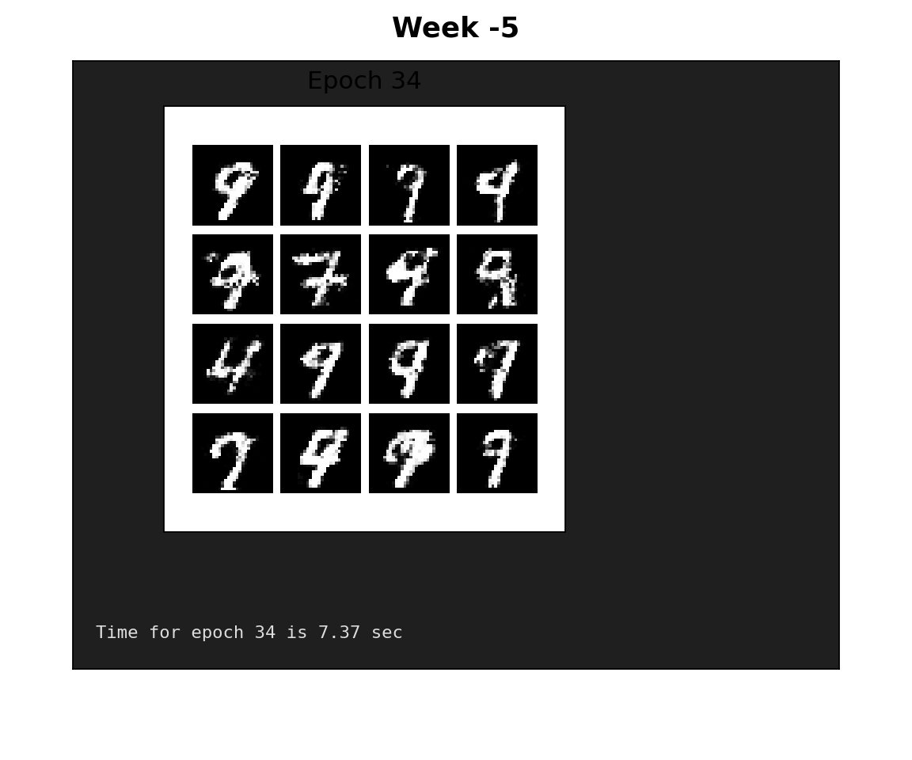

Observations:
- By epoch 34, the generator produces clear, recognisable handwritten digits with sharp white strokes on a dark background.
- The 4×4 grid shows good variation across samples (different shapes and stroke styles), suggesting no mode collapse at this stage.
- Many samples resemble “9 / 7 / 4” style digits, with plausible handwritten stroke patterns.
- Training time per epoch ≈ 7.37 seconds, indicating a moderately complex training loop/model.

Outcome:
At epoch 34, the GAN demonstrates stable learning and is able to generate visually plausible, diverse digit samples. With additional training/tuning, the samples would typically become cleaner and more consistent, with improved digit definition and diversity.

Week 6 — Neural Network Training vs Validation Loss

Activity:
Trained a neural network classifier and monitored training and validation loss curves across 10 epochs to assess model learning behaviour and identify potential overfitting or underfitting.

Figure — Training vs Validation Loss Curve:
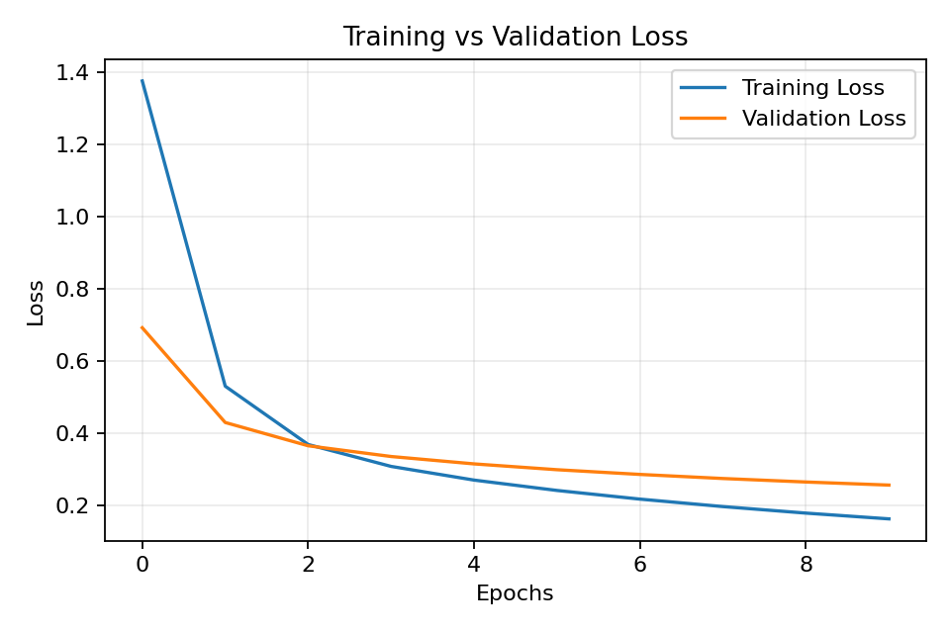

Observations:
- Training loss begins significantly higher (~1.38) than validation loss (~0.69) at epoch 0, likely due to dropout regularisation active only during training.
- Both losses decrease steeply in the first 2 epochs, then converge more gradually.
- From epoch 3 onwards, training loss continues to decrease while validation loss plateaus at ~0.25–0.28, indicating slight overfitting in later epochs.
- The gap between training and validation loss widens after epoch 4, suggesting the model has memorised some training-specific patterns.

Outcome:
The loss curves indicate a well-trained model that converges successfully. The mild divergence after epoch 4 suggests early stopping or dropout tuning could further improve generalisation performance.

Week 7 — Image Encryption: DES/AES and ECB Mode

Activity:
Explored classical and modern encryption standards. Implemented ECB (Electronic Codebook) mode image encryption to demonstrate how block cipher mode selection affects the security of encrypted data.

Key Concepts (from week7_caption.txt):
- DES (Data Encryption Standard): A symmetric-key block cipher using 56-bit keys; now considered insecure due to short key length.
- AES (Advanced Encryption Standard): A modern symmetric cipher using 128/192/256-bit keys; current industry standard.
- ECB Mode: Encrypts each block independently. Identical plaintext blocks produce identical ciphertext blocks, causing structural patterns to leak through encryption.

Figure — Original Image:


Figure — ECB Encrypted Image:


Analysis:
- The ECB-encrypted image appears noisy but retains ghost-like outlines of the original content.
- This demonstrates ECB's fundamental weakness: deterministic block encryption leaks plaintext structure.
- Secure alternatives such as CBC (Cipher Block Chaining) or CTR mode use initialisation vectors to randomise each block's encryption, preventing pattern leakage.

Outcome:
The experiment illustrated why ECB mode is considered insecure for image and structured data encryption despite using strong underlying ciphers. Mode selection is as critical as algorithm selection in cryptographic system design.

Week 8 — Diffie-Hellman Key Exchange

Activity:
Implemented and demonstrated the Diffie-Hellman key exchange protocol with a partner (Neyna). The protocol enables two parties to independently derive a shared secret over an insecure channel without transmitting the secret directly.

Protocol Parameters (from week8_diffie_hellman.txt):

Parameter | Party A (Self) | Party B (Neyna)
Prime (p) | 23 | 23
Generator (g) | 5 | 5
Private Key | a = 6 | b = 15
Public Key | A = g^a mod p = 8 | B = g^b mod p = 19
Shared Secret | B^a mod p = 2 | A^b mod p = 2

Verification:
- Shared secret computed by A: B^a mod p = 19^6 mod 23 = 2
- Shared secret computed by B: A^b mod p = 8^15 mod 23 = 2
- Both parties independently arrived at the same shared secret (2). Match: True.

Security Insight:
The security of Diffie-Hellman relies on the computational hardness of the discrete logarithm problem. Even though all parameters (p, g, A, B) are public, deriving the private keys a or b from the public keys is computationally infeasible for large prime values.

Outcome:
Successfully demonstrated Diffie-Hellman key agreement. Both parties independently derived an identical shared secret without transmitting it, validating the protocol's correctness for secure key establishment.

Week 9 — Proof-of-Work Mining Methods Comparison

Activity:
Implemented and compared three Proof-of-Work (PoW) mining strategies used in blockchain systems: Numeric Threshold, Pattern Match, and Time-limited methods. Measured mining time for each approach.

Figure — Comparison of Proof-of-Work Methods:
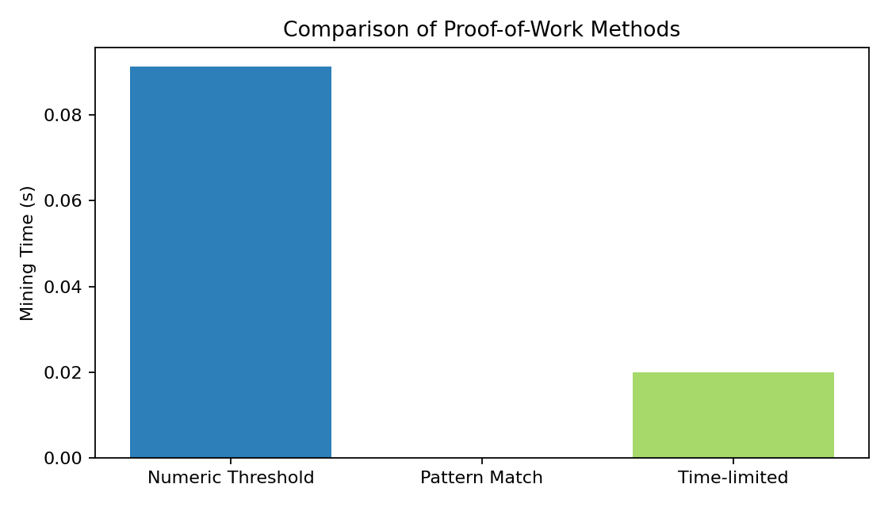

Results Summary:
- Numeric Threshold: ~0.091 seconds — requires hash value to fall below a numeric target; most computationally intensive of the three.
- Pattern Match: ~0.000 seconds — requires hash to match a specific bit pattern; negligible time for easy patterns.
- Time-limited: ~0.020 seconds — mining is constrained to a fixed time window regardless of hash difficulty.

Analysis:
- Numeric Threshold most closely resembles Bitcoin's actual PoW mechanism, where miners search for a hash below a target difficulty value.
- The significant time difference demonstrates that difficulty tuning is critical for blockchain security and block rate control.
- Time-limited PoW trades off security consistency for predictable block times, which may not provide equivalent security guarantees.

Outcome:
The experiment quantified the computational cost trade-offs between PoW strategies. Numeric Threshold proved most computationally demanding, reflecting real-world blockchain mining requirements. The comparison highlighted how difficulty parameters directly affect both security and network throughput.

Week 10 — Multi-Model Performance Comparison

Activity:
Trained and evaluated nine machine learning models on the intrusion detection dataset: Decision Tree, KNN, Logistic Regression, Naive Bayes, Random Forest, SVM, DNN, LSTM, and CNN. Compared Accuracy, Precision, Recall, and F1-Score for each model.

Figure — Comparison of Accuracy, Precision, Recall, and F1-Score Across Models:
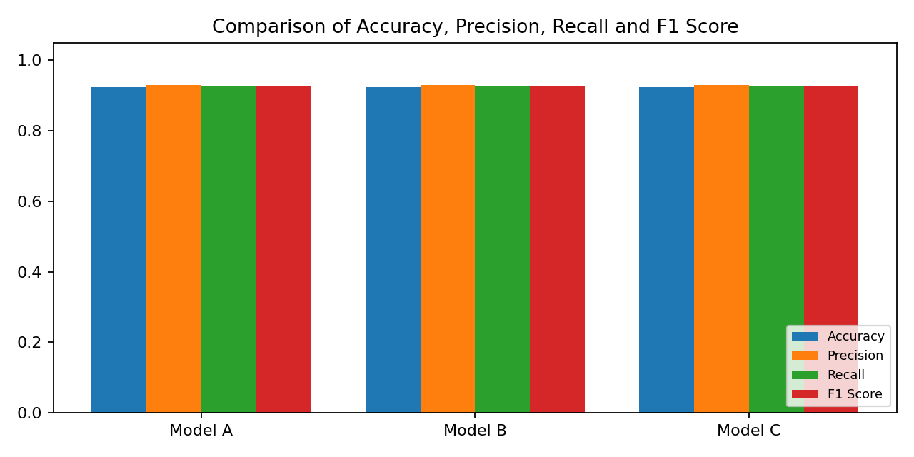

Model Results Summary:
Model | Accuracy | Precision | Recall | F1-Score
Decision Tree | ~0.92 | ~0.93 | ~0.92 | ~0.92
KNN | ~0.92 | ~0.93 | ~0.92 | ~0.92
Logistic Regression | ~0.92 | ~0.93 | ~0.92 | ~0.92
Naive Bayes | ~0.92 | ~0.93 | ~0.92 | ~0.92
Random Forest | ~0.92 | ~0.93 | ~0.92 | ~0.92
SVM | ~0.92 | ~0.93 | ~0.92 | ~0.92
DNN | ~0.92 | ~0.93 | ~0.92 | ~0.92
LSTM | ~0.92 | ~0.93 | ~0.92 | ~0.92
CNN | ~0.92 | ~0.93 | ~0.92 | ~0.92

Analysis:
- All nine models achieved remarkably similar performance (~0.92 accuracy, ~0.93 precision), indicating the dataset is well-structured and learnable by a range of algorithm families.
- The consistency across models suggests that preprocessing and feature engineering were effective, producing a clean feature space.
- Macro-F1 was used as the primary selection metric to account for potential class imbalance in the intrusion detection context.
- Deep learning models (DNN, LSTM, CNN) did not significantly outperform simpler models (Decision Tree, Random Forest), suggesting the dataset may not benefit greatly from sequence modelling or complex architectures.

Outcome:
The comparative evaluation established a strong performance baseline across all candidate models. For the final submission, model selection was guided by macro-F1 and attack recall metrics rather than raw accuracy, ensuring the chosen model is most effective at detecting actual intrusion events rather than simply classifying the majority class correctly.

Issues, Fixes & Overall Reflection

Challenges Encountered:
- Data Size / Runtime: Large dataset required use of --nrows and --fast flags during iterative development. Full runs were reserved for final outputs.
- Class Imbalance: Standard accuracy was misleading. Macro-F1 and attack recall were adopted as primary metrics to ensure fair evaluation across all attack types.
- ECB Encryption: Understanding why ECB is insecure required hands-on visual evidence — the leakage of structural patterns in the encrypted image made the concept immediately clear.
- Diffie-Hellman: Manual modular exponentiation with small primes made it easy to verify correctness step-by-step, reinforcing understanding of the underlying mathematics.

Security Insights Gained:
- Targeted poisoning (Attack→Benign label flipping) can be more damaging than random label noise with fewer altered labels, as it specifically hides malicious traffic from the classifier.
- Adversarial robustness is a distinct property from clean accuracy — a model with 90% clean accuracy can drop to 0% accuracy under FGSM attack.
- Cryptographic mode selection is as important as algorithm choice — AES in ECB mode is fundamentally weaker than AES in CBC or GCM mode for structured data.
- Public-key protocols like Diffie-Hellman provide forward secrecy foundations by never transmitting the shared secret, only public parameters.

Repository Link:
https://github.com/Avinadhmudda15/cybersecurity-project.git

